**JAVA UNIT TESTING**

**Date 26/02/2021**

**Order.java**

public class Order {

private int quantity;

private String itemName;

private double price;

private double priceWithTex;

public Order() {

}

public Order(int quantity, String itemName, double price) {

this.quantity = quantity;

this.itemName = itemName;

this.price = price;

}

public int getQuantity() {

return quantity;

}

public Order setQuantity(int quantity) {

this.quantity = quantity;

return this;

}

public String getItemName() {

return itemName;

}

public Order setItemName(String itemName) {

this.itemName = itemName;

return this;

}

public double getPrice() {

return price;

}

public Order setPrice(double price) {

this.price = price;

return this;

}

public double getPriceWithTex() {

return priceWithTex;

}

public Order setPriceWithTex(double priceWithTex) {

this.priceWithTex = priceWithTex;

return this;

}

}

**OrderTest.java**

import org.junit.jupiter.api.Test;

import static org.junit.jupiter.api.Assertions.*;

class OrderTest {

Order order = new Order(29, "Laptop", 37000.00);

**@org.junit.jupiter.api.Test**

**void testGetQuantity()** {

assertEquals(29, order.getQuantity());

}

**@org.junit.jupiter.api.Test**

**void testSetQuantity()** {

int quantity = 12;

Order ord = order.setQuantity(quantity);

assertEquals(ord.getQuantity(), quantity);

}

**@org.junit.jupiter.api.Test**

**void testGetItemName()** {

String name = order.getItemName();

assertEquals(name.equals("Laptop"), true);

}

**@org.junit.jupiter.api.Test**

**void testSetItemName()** {

String name = "HP Laptop";

Order ord = order.setItemName(name);

assertEquals(ord.getItemName().equals(name), true);

}

**@org.junit.jupiter.api.Test**

**void testGetPrice()** {

assertEquals(order.getPrice(), 37000.0);

}

@org.junit.jupiter.api.Test

void testSetPrice() {

double newPrice = 40000.0;

Order ord = order.setPrice(newPrice);

assertEquals(ord.getPrice(), newPrice);

}

**@org.junit.jupiter.api.Test**

**void testGetPriceWithTex()** {

double expectedRes = order.getPrice() + (order.getPrice() / 20);

order.setPriceWithTex(expectedRes);

assertEquals(order.getPriceWithTex(), expectedRes);

}

**@org.junit.jupiter.api.Test**

**void testSetPriceWithTex()** {

//5% tax on price

double newPrice = order.getPrice() + (order.getPrice() / 20);

Order ord = order.setPriceWithTex(newPrice);

assertEquals(ord.getPriceWithTex(), newPrice);

}

}

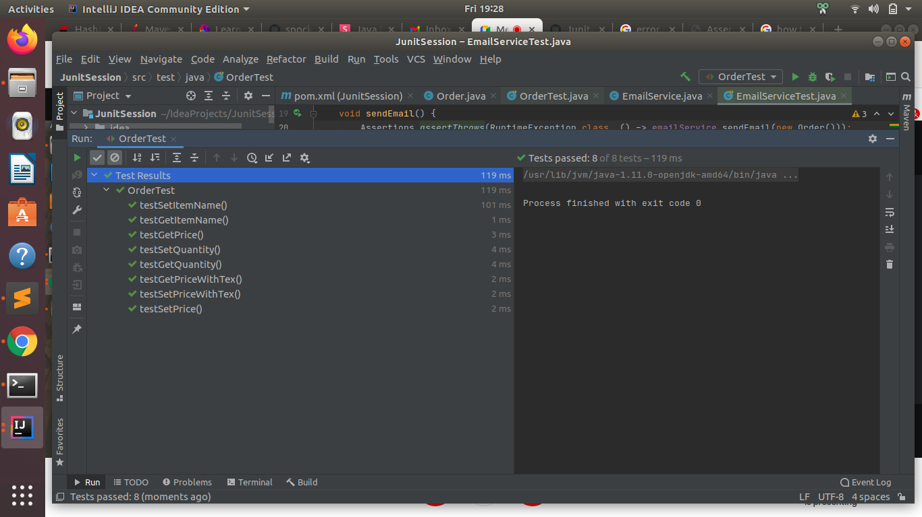

**EmailService.java**

public class EmailService {

private static EmailService instance;

public EmailService() {

}

public static EmailService getInstance() {

if (instance == null) {

instance = new EmailService();

}

return instance;

}

void sendEmail(Order order) {

// implementation goes here

throw new RuntimeException();

}

boolean sendEmail(Order order, String cc) {

// implementation goes here

return true;

}

}

**EmailServiceTest.java**

import org.junit.jupiter.api.Assertions;

import org.junit.jupiter.api.Test;

import static org.junit.jupiter.api.Assertions.*;

class EmailServiceTest {

private EmailService emailService;

private Order order;

@Test

void shouldBeSingleInstanceOfEmailService() {

EmailService emp1 = EmailService.getInstance();

EmailService emp2 = EmailService.getInstance();

assertTrue(emp1.equals(emp2));

}

@Test

void sendEmail() {

Assertions.assertThrows(RuntimeException.class, () -> emailService.sendEmail(new Order()));

}

@Test

void testSendEmail() {

String s = "order dispatched";

assertTrue(EmailService.getInstance().sendEmail(order, s));

}

}

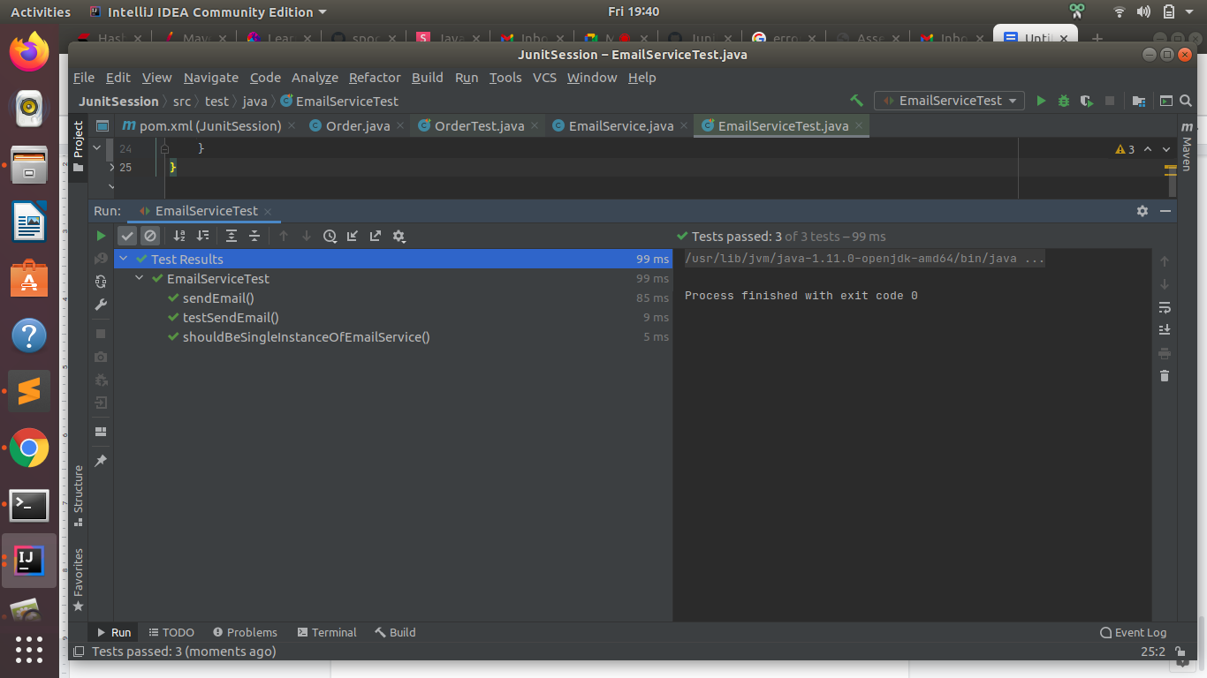

**Google doc link:** [**https://docs.google.com/document/d/1NrGLs0gt4oP2W28F0jM1Ap6xJkXTbCAMJgkNpsshMBQ/edit?usp=sharing**](https://docs.google.com/document/d/1NrGLs0gt4oP2W28F0jM1Ap6xJkXTbCAMJgkNpsshMBQ/edit?usp=sharing)